ERS2 Altimeter OPR Wind Speed and Significant Wave Height Calibration (1995-2000)
P.D. Cotton
Satellite Observing Systems
28 January 2002

1. Introduction
This note describes the calibration of the ERS2 altimeter significant wave height and ocean wind speed OPR measurements against in situ buoy data.
ERS2 OPR (v6) data were used, as supplied by CERSAT. At the time of writing data from April 1995 to December 2000 were available. Processing of ERS2 data for 2001 had been delayed following problems experienced from January 2001 onwards with spacecraft mis-pointing due to the failure of on board gyroscopes.
The in-situ data were taken from 24 US National Data Buoy Centre (NDBC) buoys, 6 offshore buoys operated by the UK Meteorological Office (UKMO) , and from 7 Canadian offshore buoys courtesy of Environment Canada (EC). The NDBC data cover the whole period (1995-2000), the UK and Canadian data only cover 1995-1997. The UK and Canadian buoy data for this particular study were offline data that had been provided by the UK Meteorological Office and Environment Canada for an earlier study (reported in Cotton, 1998). Thus these data had experienced a different data processing chain to the online UK and Canadian buoy data considered in the TOPEX, GFO and ERS2 rgdr calibration reports which are sisters to the present report. The online UKMO and CMEDS data were only retrieved from January 2001 onwards, and so did not coincide with the ERS2 OPR data that were available.

2. Data Processing

ERS2 OPR Data
For this study we used significant wave height and wind speed data extracted directly from the 1 Hz ERS2 OPR (v6), covering the period April 1995 to December 2000. Apart from quality checks (see below) no further processing of these records took place.

ERS2 OPR v6 Quality Checks

Parameter | Check
OPR flags | 0,1-3,7,8
σ0 range | 0-30
Hs range | 0-25
U10 range | 0-50
sdHs range | 0.000001< sdHs <2.0  .or. sdHs <2.0Hs
sdH range | <0.3

Buoy Data
Hourly records of wind, wave and other surface meteorological data were retrieved from the ocean data buoys. More details are given in a calibration report for Geosat Follow On (http://www.satobsys.co.uk/Projects/CalVal)
Where appropriate the buoy winds were adjusted to 10m according to Dobson [1981].

Extraction of coincident altimeter/buoy data
Extraction details are given in the GFO report (see above)

Calibration Procedure
Details of the orthogonal distance/principle component regression procedure used are given in the GFO report. Results are given below.

Results
A series of ODR regressions were carried out, comparing ERS2 OPR to the NDBC, UKMO and EC buoy data, separately and together. In addition, the co-located ERS2 and NDBC data set was split into two periods 1995-97 and 1998-2000, to test for any drift in calibration. Results (Equations 1 and 2, and Tables 1 and 2) are given in terms of the indicated linear correction required for the ERS2 altimeter OPR data.

ERS2 OPR v NDBC Data

Significant Wave Height
The orthogonal distance regression on the full ERS2 OPR v NDBC data set (1995-2000) yielded the following calibration correction:
Hs(ODR) = 1.0627 Hs(ERS2 OPR) + 0.0454 rms=0.3048 m (1)
95% conf. limits 1.0521-1.0734 0.0226 – 0.0681
R² = 0.9286, N=2830

Equation (1) and Figure 1 show that, when regressed against NDBC buoy measurements, the ERS2 OPR data underestimate by about 6%. The calibration gradient of 1.0627 is significantly different from 1.0 (at the 95% level), and the intercept is significantly greater than 0.0, at 0.0454.
The co-located data range from < 0.5 to > 9 m.

10m Wind Speed
The orthogonal distance regression of ERS2 OPR with NDBC data yielded a suggested calibration correction of:
U10s(ODR) = 0.8805 U10 (ERS2 OPR) + 0.7721 rms=1.2656 ms⁻¹ (2)
95% conf. limits 0.8673-0.8936 0.6716– 0.8726
R² = 0.8495, N=2830
From the relative positions of the dashed line (perfect match between altimeter and buoy) and solid line (ODR line) on Figure 2 we can see that ERS2 OPR slightly underestimates low wind speeds and overestimates higher wind speeds (Ubuoy > 6.0 ms⁻¹). At 0.88, the gradient is significantly lower than 1.0 (at the 95% level), and the intercept is significantly higher than 0.0, at 0.71 ms⁻¹. The consequence is that for Ubuoy = 20 ms⁻¹ this overestimate reaches 1.6 ms⁻¹. The residual root mean square of the fitted data is 1.2656 ms⁻¹. The range of wind speeds covered by the data is <0.5 ms⁻¹ to > 20 ms⁻¹.
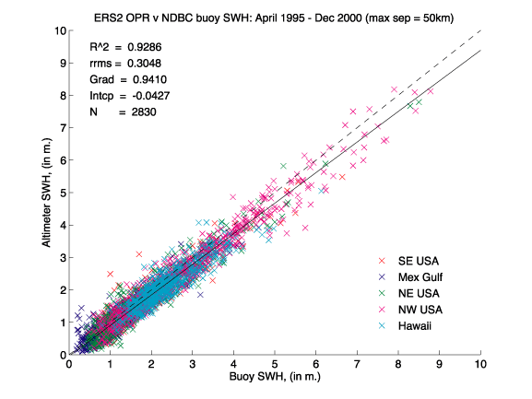
Figure 1. Co-located ERS2 OPR and NDBC buoy significant wave height data (04/95-12/00). The ODR fit is shown as a solid black line, the line of perfect match (gradient=1.0, intercept =0.0) as a dashed line.

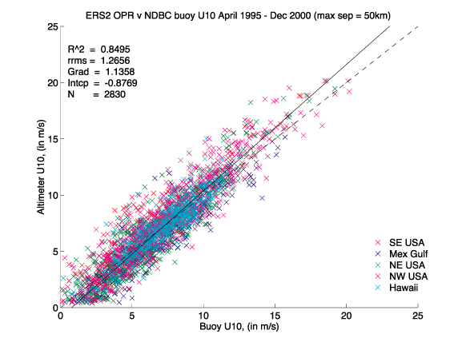
Figure 2. Co-located ERS2 OPR and NDBC buoy 10m wind speed data (04/95-12/00). The ODR line is shown as a solid black line, the line of perfect match (i.e. gradient=1.0, intercept =0.0) is given by a dashed line.

Further Comparisons
ODR regressions were carried out against CMEDS and UKMO data from 1995-97, and separately against NDBC data from 1995-1997 and 1998-2000. Results are summarised in Table 1 (for significant wave heights) and Table 2 (for 10m wind speed).

Significant Wave Height

Data set | Gradient | 95% conf interval | Intercept (m) | 95% conf interval | r.r.m.s (m) | R² | N
Hs UKMO 1995-1997 | 0.9952 | 0.9660 1.0244 | 0.1566 | 0.0733 0.2398 | 0.3959 | 0.9297 | 329
Hs EC 1995-1997 | 1.1235 | 1.0737 1.1733 | -0.0053 | -0.1478 0.1372 | 0.3444 | 0.9407 | 124
Hs NDBC 1995-1997 | 1.0611 | 1.0456 1.0765 | 0.0350 | 0.0016 0.0684 | 0.3092 | 0.9254 | 1413
Hs NDBC 1998-2000 | 1.0659 | 1.0512  1.0807 | 0.0528 | 0.0218  0.0838 | 0.3000 | 0.9319 | 1417
Hs NDBC 1995-2000 | 1.0627 | 1.0521 1.0734 | 0.0454 | 0.0226 0.0681 | 0.3048 | 0.9286 | 2830
Hs all buoys 1995-2000 | 1.0563 | 1.0466 1.0660 | 0. 0588 | 0.0370 0.0807 | 0.3218 | 0.9299 | 3317
Table 1. Linear calibration coefficients for ERS2 altimeter OPR significant wave height derived from orthogonal distance regressions against in situ NDBC, UKMO and EC data.

Considering first the regressions with the NDBC data, we see that there is no significant difference in the regression results (gradient or intercept) for either the two separate periods or the single combined period. If any drift in the calibration or ERS2 OPR Hs data has occurred, it was too small to be detected with this data set. These regressions all agree the ERS2 OPR data underestimate by about 6%, and also require a further small constant addition of 3-5 cm. All show a residual root mean square of close to 30cm.
Both the EC and UKMO co-located data sets show a larger scatter (r.r.m.s. of 34 cm and 40 cm respectively). The EC regression results show a higher gradient (1.12) than the NDBC regression, though the intercept is not significantly different. In contrast, the UKMO data show a significantly lower gradient and higher intercept than both the EC and NDBC data. However, the “offline” UKMO buoy data were only provided at the reduced resolution of 0.5m (the other data were provided at a resolution of 0.1m), which will have effected the OD regression results.
In principle the author would prefer to make use of in situ data covering the widest range of ocean locations and conditions possible to derive a calibration for altimeter measurements, to ensure that a properly representative calibration were derived. However, in this instance was felt that the inclusion of the UKMO and (to a lesser extent) the EC data would only serve to downgrade the quality of the in situ data. It is thus recommended that the calibration given in Equation 1, and the bottom row of Table1, be applied to ERS-2 OPR data.

10m wind Speed

U10 Data set | Gradient | 95% conf interval | Intercept (m) | 95% conf interval | r.r.m.s (m) | R² | N
UKMO 1995-1997 | 0.8122 | 0.7797 0.9257 | 0.6222 | 0.3188 0.9257 | 1.3856 | 0.8741 | 329
CMEDS 1995-1997 | 0.9125 | 0.8344 0.9907 | 0.4278 | -0.2703 1.1259 | 1.5348 | 0.7958 | 124
NDBC 1995-1997 | 0.8767 | 0.8581 0.8953 | 0.8412 | 0.7009 0.9815 | 1.2563 | 0.8482 | 1413
NDBC 1998-2000 | 0.8809 | 0.8626 0.8992 | 0.7120 | 0.5694 0.8546 | 1.2739 | 0.8510 | 1417
NDBC 1995-2000 | 0.8805 | 0.8673 0.8936 | 0.7721 | 0.6716 0.8726 | 1.2656 | 0.8495 | 2830
All buoys 1995-2000 | 0.8643 | 0.8522 0.8763 | 0.8011 | 0.7057 0.8964 | 1.3182 | 0.8456 | 3317
Table 2. Linear calibration coefficients for ERS2 altimeter 10 m wind speed derived from orthogonal distance regressions against in situ NDBC, UKMO and CMEDS data.

Again we are unable to detect any drift in the Ers2 OPR calibration (for U10 measurements) from the co-located ERS2 NDBC data set. There is no significant different between the results of any of the regressions with these data. They regressions all agree that the ERS2 OPR data overestimate by about 12%, and also require a further constant addition of 0.7-0.8 ms⁻¹. These regressed ERS2/NDBC data all show a residual root mean square of just over to 1.25 ms⁻¹.
Again, both the EC and UKMO co-located data sets show a larger scatter (r.r.m.s. of 1.53 ms⁻¹ and 1.39 ms⁻¹respectively). However, none of the regression results are significantly different from the NDBC results. The “offline” UKMO buoy data were provided at the reduced resolution of 1 knot, roughly equivalent to 0.5 ms⁻¹, whereas the other buoy data were provided at a resolution of 0.1 ms⁻¹). Although it might be expected that this restricted resolution will have effected the OD regression results, the consequences are perhaps not as clear as for the Hs data.
Again the author would prefer to use as much in situ data as possible, but it was again felt sensible to recommend a calibration derived from NDBC data only. It is thus recommended that the calibration given in Equation 2, and the bottom row of Table2, be applied to ERS-2 OPR data.

Summary
A comparison of ERS2 OPR data with co-located buoy data indicates that the ERS2 OPR significant wave height and wind speed measurements (prior to January 2001) continued to be of high quality.
Because of doubts about the quality of the UKMO and (to a lesser extent) the EC buoy data it is recommended that calibrations are derived from comparisons against NDBC data only. The appropriate ODR regressions indicate that the ERS2 OPR data underestimate significant wave height by 6.6% (Equation 1). The wind speed regressions (Equation 2) indicate a gradient significantly lower than 1.0 (0.88 when compared to the buoy data) and an intercept significantly higher than 0.0 (0.77 when compared to the buoy data). The combined effect of this calibration is to raise lower wind speeds, and reduce higher ERS2 OPR winds. The transition occurs close to 6.0 ms⁻¹.
It has already been noted that the ERS2 satellite suffered mispointing problems from January 2001 inwards, following gyroscope failures. New attitude control software has been put in place, but it is possible that the quality of ERS2 OPR (and rgdr) wind and wave data may have been affected.

References
Cotton, P. D., 1998, A feasibility study for a global satellite buoy inter-calibration experiment, SOC Research and consultancy report, No. 26, Southampton Oceanography Centre, Southampton, UK, 73 pp.
Dobson, FW, 1981: Review of Reference Height for and Averaging Time of Surface Wind Measurements at Sea, Marine Meteorology and Related Oceanographic Activities Report No. 3, WMO, Geneva, 64pp.
P.D. Cotton
Satellite Observing Systems
15, Church Street Phone +44 (0)1483 421213
Godalming, (direct +44 (0)161 439 4768)
Surrey GU7 1EL, UK d.cotton@satobsys.co.uk

