BNSC Service Mission Support (SMS) Programme

Ocean Currents from space

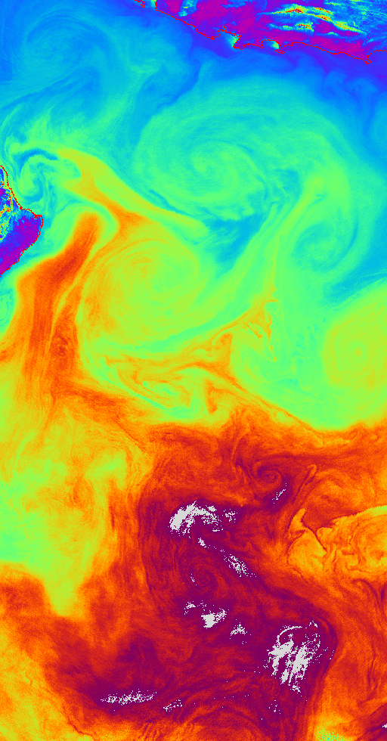

Role of SST in the determination of Ocean Currents

Report for WP32

Document No: OC-REP-3/02
Issue No: Draft
Date: 31st July, 2002
Customer: BNSC SMS Programme
Prepared by: ……………… C T Mutlow
Authorised: ………………

Contents

1. Introduction 2
2. The Methods and Examples of Retrieved Velocity Fields 2
2.1 Subjective Feature Tracking (SFT) 2
2.2 Maximum Cross-Correlation Method (MCC) 3
2.3 Inversion using the Heat equation 4
2.4 SST as a proxy for SSH 8
3. Requirement for an SST Observing System to Determine Ocean Currents 9
4. Mission Characteristics 11
4.1 SST data from the imager 11
5. Technical Concept 12
6. General Requirements 12
6.1 Payload Description 12
6.2 Instrument Data Formatter 18
7. Platform 18
7.1 Platform Requirements 19
7.2 Platform Survey 20
8. Launcher 20
8.1 Basic Requirement 20
8.2 Launch Vehicle Survey 20
9. Ground Operations 21
9.1 Orbit /Pass Characteristics 22
9.2 Ground Stations 22
9.3 Operations Centre Tasks 23
9.4 Additional Ground Station Support 24
10. Science Data Centre 24
11. Concluding Remarks 25
12. References 26

Role of SST in the determination of Ocean Currents

Introduction
Over the last 20 years or so since the development of Earth Observation satellites many significant advances have been made in our understanding of ocean because of the new detailed observations of the global oceans that have become available from satellite-based remote sensing systems. Studies of ocean circulation have particularly benefited from the sea surface height (SSH) data sets produced by the various radar altimeter systems that have flown (i.e. Geosat, ERS-1/2, TOPEX/POSEIDON). The reason for the use of satellite altimetry is that it provides direct information about the ocean circulation (assuming the flow is predominantly geostrophic) and it as has much better spatial and temporal coverage than could ever be achieved on the global scale with in situ sensors.
Another, currently less well-exploited and potentially rich source of information about the ocean circulation, and which can also be observed from space, is sea surface temperature (SST). SST gives independent but less direct information concerning the ocean circulation because SST is, at least to first order anyway, is advected as a passive tracer. The consideration of SST as a passive tracer does involve some assumptions, namely that SST and sea surface salinity (SSS) are anti-correlated such that the density of seawater remains constant. Thus, any unaccounted for horizontal density gradients would have a dynamical effect via the geostrophic balance, however it is currently not possible to test this assumption as we are currently unable to observe SSS on the same spatial scales as SST.
From our review of the literature there does seem to be strong role for satellite-SST observations in the determination of ocean circulation from space. There is a series of papers describing four basic techniques for obtaining ocean circulation from space by inferring ocean surface velocities from successive SST images: 1) Subjective Feature tracking (SFT), 2) the Maximum cross-correlation statistical method (MCC), 3) by inversion of the heat equation (INV), and 4) by assimilation of SST as a proxy or supplement to SSH observations (SST/SSH).

The Methods and Examples of Retrieved Velocity Fields

Subjective Feature Tracking (SFT)
There are numerous papers on this method in the literature and a typical example of these is that by Svejkovsky (1988). In this paper the SFT technique is applied to obtain surface currents from the displacement of features seen in sequential images from AVHRR and CZCS. The method is extremely simple and relies on a human operator to identify candidate features in the images and register their displacement with time in subsequent images. The method is extremely manually intensive and relies heavily on decisions made by the operator to identify suitable features and properly track their progress. It is inevitably a very subjective process and in practise provides no quantitative error statistics to support the retrieved surface velocities. Another limitation of the method is that the regions of the ocean over which velocities can be retrieved are usually sparse, as the clear strong features needed for the method to be reliable occur infrequently and in fairly localised parts of the ocean.
The method is however easy and cheap to implement if and when suitable SST or ocean colour data sets are available, and has a particular applicability to regional studies (i.e. when typically only small numbers of images are being processed, and it be comes feasible to process data using this manually intensive method).
The obvious limitation of the method is that it can only be used when suitable ocean features can be seen in images. Monitoring of surface flow is therefore only possible in regions with heterogeneous mesoscale thermal features and for them to be reliably tracked over time they must be persistent and all the scenes cloud-free. The extent to which any given ocean feature maintains its shape and identity between subsequent images greatly affects the tracking precision, and therefore ultimately the accuracy of the derived velocities. This argues for keeping successive images as close together in time as possible so as to minimise the evolution of any features. But in reality this approach does not work particularly well because of the relatively small movements that occur on these short time scales are difficult to detect given the spatial resolution etc. In this situation it is the dominance of spatial sampling and image mis-registration errors that lead to large uncertainties in the retrieved velocities.
Current experience indicates that a for sensors with 1km nominal instantaneous field of view (IFOV) a 12 hour image-to-image time interval is the minimum for keeping track errors within acceptable bounds. Hence, the technique is not really useful in regions where surface features evolve rapidly, such as in areas with strong tidal flows or during periods of strong wind-driven mixing.

Maximum Cross-Correlation Method (MCC)
This method is a further development of the SFT method (See Kelly and Strub (1992) for example) that makes it more rigorous in the mathematical sense, and which uses the statistical characteristics of the image to allow feature tracking to be automated and more objective as the automation removes the need for subjective decisions from an operator.
The procedure is fairly straightforward and works in the following way. A sub-region of an initial image is cross-correlated with a sub-region of the same size in a subsequent image. This is done by searching for the location in the second image that gives the maximum cross-correlation coefficient with the sub-image from the first image. The displacement of the features contained in the first sub-image is assumed to be the distance between its initial location and the centre of the sub-region in the second image with the maximum cross-correlation. The size of the portion of the second image that is searched for a correlation depends on the displacements that are physically reasonable based on typical surface velocities and the time between the subsequent images. The size of the sub-region used in the cross-correlation calculation is chosen to be large enough to contain a number of independent features in the SST field. There is tendency for the cross-correlation calculations to be dominated by the larger scale features in the fields so to reduce this prior to cross-correlation the data is high-pass filtered in wavenumber.
Typically correlation tiles with a size of 25 pixels square are chosen; a) as these are small enough to resolve ocean features such as jets (which have typical scales of 20-40km) but b) they are also large enough to contain a number of smaller distinctive features with scales of 5-10km.
Improved formulations of this method, which apply more physical constraints to obtain more robust results have been reported by Simpson and Gobat (1994).
From Kelly and Strub (1992), the optimal time separation for successive images used in the MCC method is 4-6 hours.
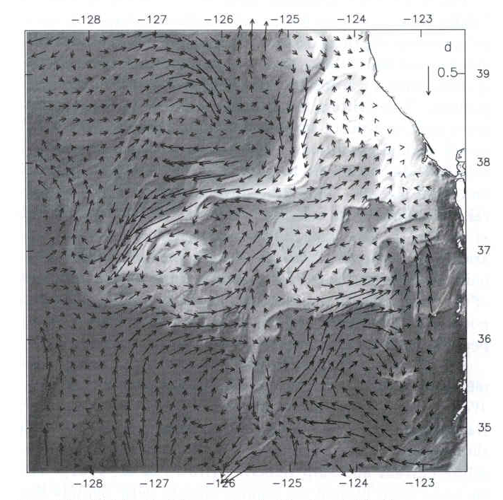
Figure 1 After Kelly and Strub (1992) (fig 4(d)) MMC retrieved velocity vectors superimposed on an AVHRR image from the sequence used to derived the velocity estimates. (The vector in the top right-hand corner of the image shows a 0.5ms⁻¹ velocity vector.)

Inversion using the Heat equation
The heat conservation equation in its simplified form for a well-mixed ocean from depth h to the surface can be written as (Vigan et al., 2000):
$\frac{∂T}{∂t}+u\frac{∂T}{∂x}+v\frac{∂T}{∂y}=κ∇^{2}T+\frac{Q}{{hρ}_{0}C_{p}}−\frac{{ΔTω}_{e}}{h}$where T is temperature, u, v are the horizontal velocities, K is a coefficient of horizontal diffusion, p_{o} is the average density of seawater, C_{p} is the specific heat capacity of sea water, Q is the net heat flux at the surface, ΔT is the temperature difference between the mixed layer and the water below, w_{e} is the entrainment velocity at the bottom of the mixed layer.
To estimate the surface velocities pairs of temperature fields separated in time by the period δt are used. The temperature gradients are calculated from the mean temperature fields. Diffusion can be neglected if the time step between successive fields is short enough for eddy diffusion not to affect the temperature fields significantly. There is an optimal temporal lag δt between images for the inversion: if δt is too large the velocity field will change from one image to the next. Alternatively, if δt is too small measurement errors will dominate the temporal derivative of SST. From Kelly and Strub (1992) and Vigan et al. (2000), the preferred value of δt is approximately 12 hours.
The source terms $Q/({hρ}_{0}C_{p})$ and $({{ΔTω}_{e}}/h)$ are not known at high spatial resolution so can be represented by a single term S. Thus the equation becomes
$\frac{∂T}{∂t}+u\frac{∂T}{∂x}+v\frac{∂T}{∂y}=S$The velocities u, v cannot be estimated from the above equation alone and further constraints are required. These constraints applied by treating the flow as quasi-geostrophic using the horizontal divergence and horizontal vorticity as regularizing constraints on u and v. Thus the inversion seeks a flow that minimises the cost function
$H_{1}(u,v)=(\frac{∂T}{∂t}+u⋅∇T−S)^{2}+α^{2}(∇⋅u)^{2}+β^{2}(∇×u)^{2}$
Where T is the temperature of the mixed layer, u is the horizontal velocity at the surface and S is the SST source term (as above). The variable α and β are penalty coefficients chosen from simulations by setting a threshold on the misfit of the heat balance define as $ε=\sum{(∂_{t}T+u}∇T−S{)^{2}}/{\sum{(∂_{t}T)^{2}}}$this is done to constrain the range of solutions that are possible.
Vigan et al. estimated sea surface velocity fields over the Brazil-Malvinas Confluence region from sequences of AVHRR SST images. The velocity fields they estimated showed good agreement with in situ data and suggest that the method yields velocities error bars of better than 15% in magnitude and 22° in direction. They noted that there were limitations to the method: a) the images needed to show high spatio-temporal variability to be of use, 2) in the region of the Western Boundary Currents it is usually very cloudy so very few image pairs are usable, and 3) a number of errors emerge from the form of the constraint used to invert the heat equation, namely the divergence and vorticity.
Examples of typical velocity retrievals are shown in the following figures from Kelly and Strub (1992) and Vigan et al. 2000.
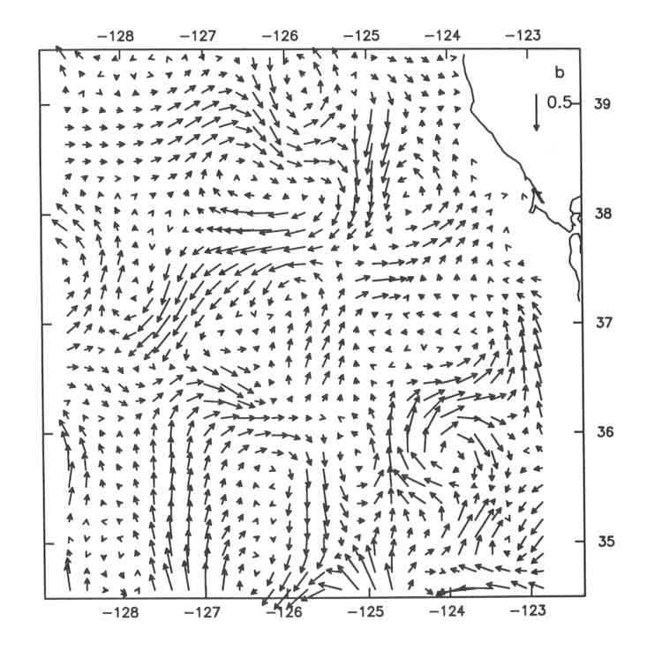
Figure 2 Velocity vectors obtained from the inversion of the heat equation. (The vector in the top right-hand corner of the image shows a 0.5ms⁻¹ velocity vector.) (After Kelly and Strub (1992) (fig 5(d)))

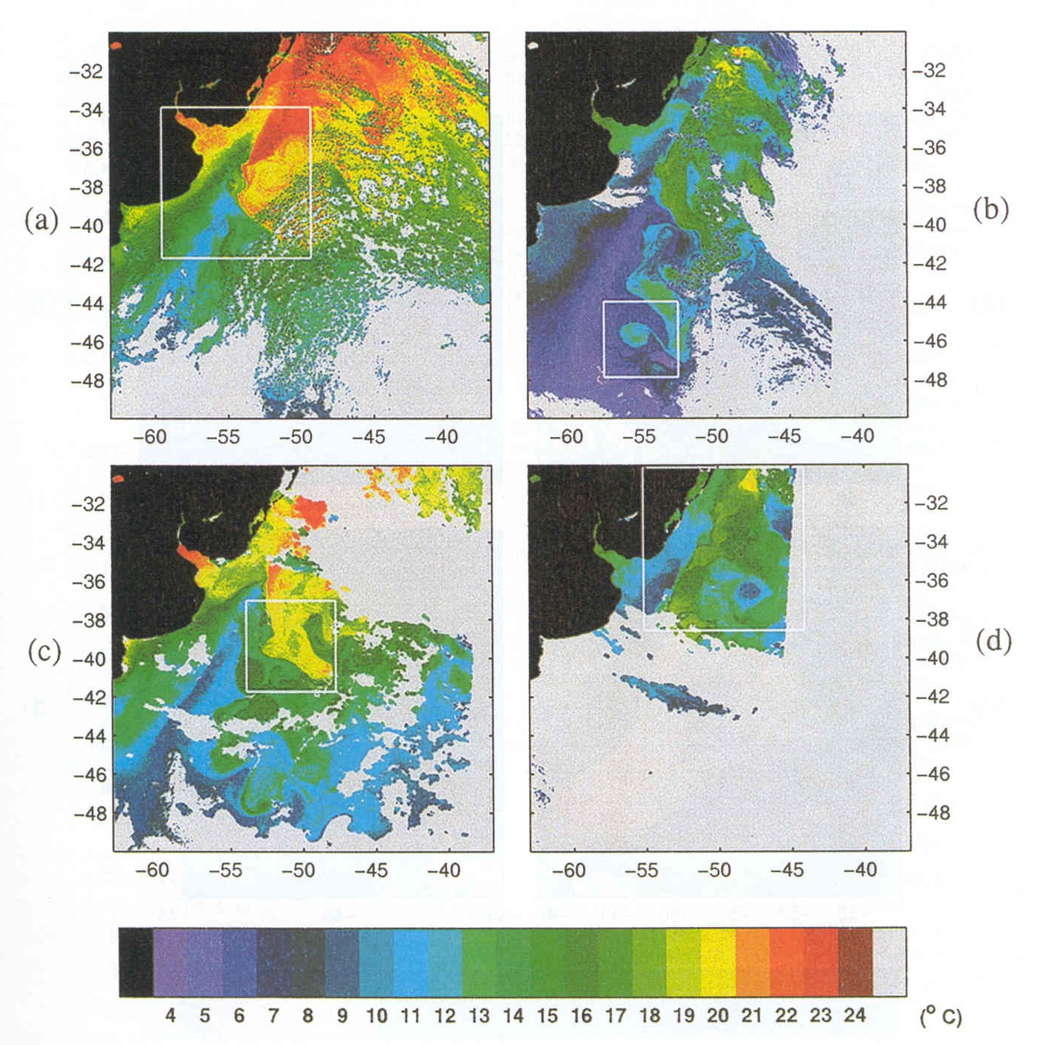
Figure 3 (a) Sea surface temperature (SST) image of the A series showing a summer situation of the area on March 10, 1995. The Brazil Current (BC) (red) meets the colder Malvinas Current (MC) (blue) at ~38°S offshore of the Rio de la Plata river estuary. (b) SST image of the B series (September 27, 1995) exhibiting warm core eddy Leon. (c) SST image of the C series (December 2, 1995) showing a large eddy detaching from the BC overshoot at ~40°S. (d) SST image spanning the cold-core eddy Jules event (September 7, 1995). (After Vigan et al. (2000) (Plate 1).)

Figure 4 Surface velocity field estimated through inversion of an 800x800 km subarea of image pair (A3,A4) of the A series (i.e. area shown in (a) in Figure 3). This field represents the average velocity of an acceptable family of solutions. Surface velocities reach 0.7 ms^{-l} in the Brazil Current, 0.6 ms^{-l} in the Malvinas Current and 1.3 ms^{-l} in the jet. The position of the current meter mooring array and the 200 m isobath are superimposed. (After Vigan et al. (2000) Figure 2a.)

SST as a proxy for SSH
SSH data has traditionally been used as the starting point for the determination of ocean currents, however the spatial and temporal coverage of the global oceans by altimeter data is relatively sparse and limits what can be achieved. To improve coverage it would be advantageous use a more readily available and more regularly sampled data set. To this end, Jones et al. (1998) explored the correlations that are known to exist between SSH and SST, a physical property of the ocean that is routinely sampled at higher spatial and temporal resolution than SSH. They employed SSH data obtained from the TOPEX/POSEIDON (T/P) radar altimeter and SST observations from the ATSR-1 in a study of data from the South Atlantic. At some locations during the month of January 1993 they found remarkable agreement between T/P geostrophic vectors and the SST field, with meanders in the geostrophic flow of the Agulhas Return Current closely following isotherms. Their pilot study showed that the relationship between SST and SSH (at least at small and intermediate scales) can be used to interpolate altimeter data and to improve eddy statistics, their work also shows somewhat surprisingly that there appears to be no sensitivity to the diurnal thermocline as they found no difference between the correlations whether they chose day or night SST.
Recent work by Lea (2001) has extended this further and demonstrated that SST can be satisfactorily used in ocean model assimilations as a proxy for SSH in the determination of ocean circulation. In his experiments Lea compared the results from SSH-only assimilations, SST-only assimilations and combined SST and SSH assimilation. He addressed the question of whether SST observations are as useful as SSH in determining the flow and SSH field. His findings were that the current level of SST observations produced an improved SSH assimilation field when compared to the more sparsely observed SSH. The improvement in the assimilation results using SST over SSH assimilation is generally relatively small, despite the much larger numbers of SST values available, because point for point the direct information provided by an observation of SSH is more powerful than the more indirect information given by an SST observation. The key result here is however that the SST assimilation gives very similar results to those from the SSH assimilation, and do a significantly better job of defining the positions of major fronts than for SSH. The very best results come from a joint assimilation of SST and SST.

Requirement for an SST Observing System to Determine Ocean Currents
In the previous sections we have identified the basic methods that can be used to determine currents from SST if observations with the appropriate characteristics are available. The two basic requirements are for 1) suitable spatial and temporal sampling characteristics and 2) on the accuracy and precision of the observations.
The data requirements for the SFT method are not particularly stringent; in fact all that is required is sufficient spatial resolution and image contrast for specific features to be identified in subsequent images. This method is usually applied only on an “ad hoc” basis in relatively simple case studies and therefore does not warrant a specific observing system to be established to support it, as the method can be used quite straightforwardly with existing data such as for example SSTs from AVHRR, or ocean colour observations from SeaWIFS. The main requirement is that the subsequent images clearly show the features of interest and how they have moved with time sufficiently clearly that accurate velocity vectors can be derived from them.
The other 3 methods (i.e. the MCC, inversion of the heat equation and data assimilation methods) are more exacting in their requirements. Firstly they require more accurate measurements than are needed for the subjective methods, so data of the radiometric quality of AVHRR represents a minimum requirement in SST accuracy and precision (i.e. 0.5 – 0.7K). In addition, the heat equation and data assimilation methods also require a “good” level of atmospheric correction to avoid atmospheric effects being misinterpreted as features in the SST field. This high level of atmospheric correction can only realistically be achieved with a sensor of the ATSR-class using a dual angle algorithm to give SST to better than 0.3K. Further, the temporal and spatial aspects of the sampling become more important, in that sub-images used need to contain sufficient numbers of moving features for the statistical methods to work. The sensor requires sufficient spatial resolution that clouds can be readily identified and removed from the data set, thus requiring the sensor to resolve objects the size of typical small cumulus clouds (i.e. objects of order 1km in size at nadir). These radiometric and spatial requirements rule out the use of microwave SST sensors as they simply cannot achieve the performance required; typical microwave radiometers have spatial resolutions of 10-20km and radiometric performance that is worse than 0.5K. With these levels of performance microwave sensors simply cannot resolve the features that we are trying to track, even though they do have an all weather observing capability and can “see” through clouds.
Temporal coverage is also an issue. For the MCC method Kelly and Strub (1992) report that the optimal time separation for successive images used is 4-6 hours; a compromise between the image features decaying and the need to have a long enough period for the movement to be large enough to detect given the instrument’s limited spatial resolution. If the movement is too small compared to the sensor’s pixel size then spatial quantisation errors obviously dominate the retrieved velocity vectors.
According to both Kelly and Strub (1992) and Vigan et al. (2000) there is a different temporal sampling requirement for the heat equation method compared to the MMC method. Both papers report that for inversion of the heat equation the preferred time interval for the image separation as approximately 12-18 hours, somewhat longer than is optimal for the for the MCC method. Kelly and Strub also make the point however that both methods require that as many as possible images collected over a period of days to reduce the retrieval errors. Lea (200X) did not specify any particular requirement he merely comments that the data he has available to him already has sufficient spatial and temporal resolution.
Cloud cover will affect the coverage from any infrared SST sensor, some crude estimate of the likely effect of cloud cover on coverage can be gained from the cloud cover data provided by the International Satellite Cloud Climatology Project (ISSCP) shown in Figure 5. These are currently the best available data from which to assess cloud cover, however, they have significant limitations. Firstly, they are not separated into day and night, which is important as a some locations the diurnal cycle of cloud cover means the area is clear during some part of the day. Thus, by lumping day and night together in this way the cloud cover is inevitably over-estimated. Also the data are presented at a very coarse spatial scale, and it is well known that low spatial resolution observations over-estimate cloud cover simply because of the binary nature of the observation. A cloudy 4km pixel may only contain only 1 cloudy sub-pixel when viewed at 1km resolution but an estimate of 100% cloud cover at the 4km scale is given instead of 25% that is obtained when viewed at the higher resolution. This is because the small pixel size instruments can find the “clear holes” in the cloud cover. Hence, considerable care must be exercised when interpreting these statistics. They should be regarded as pessimistic, and almost certainly a significant over estimate of the “real” cloud amount. Experience with 1km ATSR SST data shows that the only parts of the ocean where we systematically observe clouds on a near-continuous basis and almost never see the ocean through the course of a month are largely in the active convection regions in Micronesia and the tropical Pacific, and during some months the Gulf Stream.
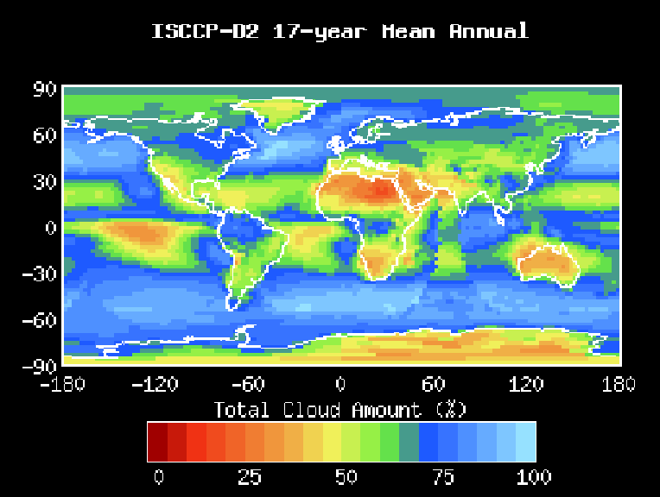
Figure 5 17 year Annual mean global cloud cover statistics from ISSCP.
The requirements for the system are:
SST: to better than 0.3K
Spatial coverage: 1km
Temporal repeat: 4-6 hours MMC methods
12 – 18 hours Heat Equation
In summary we require SST with a precision and accuracy of better than 0.3-0.5K, and a good atmospheric correction and calibration. This points towards an ATSR-class instrument with a dual view capability rather than an AVHRR instrument. Currently the only sensor able to reach this level of quality is an ATSR instrument, which unfortunately has the limitation of a 500km odd swath, so would need to be flown as part of a constellation to give the required spatial and temporal coverage. Because this sensor is currently available we have based the rest of the study on the deployment of an ATSR for ocean current determination for economic reasons. There are however new wide-swath dual-view SST sensors at the pre-phase A stage which would give considerable advantages in terms of coverage, and which because of their increased swath width give better coverage without recourse to flying constellations of sensor. This is raised at this stage to indicate that in future there may be better candidate sensors, but at this stage we have assumed an ATSR will be the chosen instrument as no development is required and because it is available now as a “working design” with low risk.

Mission Characteristics
Mission Duration | 3 years minimum
Timing requirements | No particular constraint
Dependance on other missions | None.
Orbit | Orbit height 780-800 km circular  Inclination 95-96°
Observation Geometry | Nadir viewing
Spatial and temporal scales | Global every 6 hours
Spatial and Temporal resolution | 1 km over 512 km swath
Spectral Characteristics | 1.6, 3.7, 8.7, 10.8 and 12µm
Revisit times | 3-6 hours

SST data from the imager
The nature of the SST information from the imager and the basis for the retrieval algorithm are described elsewhere (see Mutlow et al. 1995, Zavody et al. 1995, and Murray et al., 1998) so will not be discussed further here. Details of the cloud screening algorithms can be found in the ATSR User Guide on the ATSR web pages (http://www.atsr.rl.ac.uk).

Technical Concept
The “OCEAN CURRENTS” mission applies existing well-proven technology and expertise to a new and challenging problem in Earth Observation. It is planned to utilise the Heritage: of the established ATSR instruments by making use of flight spares where possible and also ground processing software available from these missions. The considerable scientific and technical experience gained from a wide range of Earth observation and planetary space activities is available to the project in the proposing groups.
The mission requirements that drive the technical requirements can be summarised as follows:
- Accurate Sea Surface Temperature
- Good temporal coverage
The instrument proposed to fulfil these requirements is:
Imager/Radiometer
An accurate multiband radiometer (ATSR) to provide the measurements in the infrared wavelengths for SST measurements.
Two main options for this instrument are being considered with regard to wavelength selection:
- The standard ATSR-2 channels at 1.6, 3.7, 10.8 and 12 μm which would provide adequate information for the mission.
- Adding an 8.7 μm channel would improve the sensor’s utility for cloud detection.

General Requirements
A typical spacecraft configuration and instrument fields of view are shown in Figure 6 and Figure 7
The instrument system design is given in section 6.1.1.1.
The proposed ground station and data handling is described in section 9

Payload Description
The payload system is described and details of the subsystem Heritage: and developments required for the “OCEAN CURRENTS” mission are outlined. The payload will consist of the following main elements
- Infrared Radiometer
- ICU /Instrument Data Formatter
- Power Conditioning and Distribution System
The proposed payload system is shown in Figure 1.
Figure 6 Payload Block Diagram

Radiometer Instrument
The infrared radiometer for measuring Sea Surface Temperature will be based on the ATSR instrument, which is a proven system having flown on ERS-1 and ERS-2 and is also to be flown on ENVISAT. The high performance is obtained by use of two views of the ground from different angles to remove the atmospheric effects and accurate on-board calibration sources viewed through the full optical system.
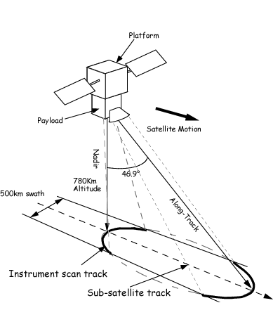
Figure 7 Payload fields of view

Instrument Overview
The proposed instrument is based on a reflecting telescope comprising an off-axis paraboloid and the plane scan mirror forms an image on a single field stop giving 1.0 km x 1.0 km instantaneous field of view at Nadir.
The rotating scan mirror directs the views of the Earth and the on-board calibration targets into the focal plane assembly. A scan period of 150ms gives 1.0 km satellite motion along track per scan and the data sample rate corresponds to 1.0 km across track at nadir.
A ROM cost for an instrument based on an ATSR sensor would be €15-20M (TBC) based on the assessment of RAL costs made for the ESA TROPEX Earth Explorer Mission Bid (This price was for a single instrument and assumed the reuse of some ATSR-1/2 flight spares which may no longer be available). If the sensor was built completely in industry the costs are likely to be somewhat higher than the RAL-based figure.
Figure 8 The basic optical layout of the proposed imager
Basic radiometer elements:
- A Focal plane assembly with optical elements including dichroics and filters to image the field stop onto a number of oversized detectors, one per channel.
- Wavelength bands centred on 3.7µm, 8.7µm, 10.7µm, 12µm for the sea surface temperature (infrared)
- A Stirling cycle cooler to cool the infrared detectors to 80K.
- A Signal conditioning chain for the detectors comprising low noise pre-amplifiers followed by signal channel processors which integrate the detector outputs across a pixel and convert the result into a 12 bit data word
- A hot and a cold blackbody infrared calibration targets and a diffuse reflector visible calibration target viewed between the nadir and along-track scans.
- Structure supporting the optical system and calibration targets acting as a stable optical bench maintaining the optical element positions during launch vibrations and providing the required optical and thermal environment.

Subsystem Status
If we reuse the ATSR-design the maturity and scope of the development required is described for each subsystem in the folloing sections.

Blackbody Calibration Targets
On board infrared temperature controlled emitters with accurate thermometry.
Heritage: Proven design flown on ATSR-1/ERS-1, ATSR-2/ERS-2 and to be flown on AATSR/ENVISAT.
Development: Potential for simplification of precision temperature sensor processing/digitisation system and mechanical arrangement.

Scan Mirror Unit
An angled plane mirror is rotated at a controlled uniform speed on a motor shaft providing the conical radiometer scan.
Heritage: The basic concept and rotational stability requirements of a plane mirror rotating on the motor shaft has been demonstrated on ATSR-1,2 and AATSR. Some improvements associated with the position encoder have taken place in going from ATSR-1 to 2 and thence to AATSR. These changes were introduced to reduce the risk of debris from lead coated bearings affecting the optical encoder.
Development: Whilst maintaining the same basic motor, bearing and shaft attachment configuration the shaft position sensing requires some improvement to be totally immune to the debris problem. e.g.inductosyn.

Cryogenic Cooler
A balanced Stirling cycle cooler is used to cool the focal plane to 80K whilst transfering an acceptably low level of mechanical vibration due to it’s operation.
Heritage: Coolers employing the same fundamental design have been used on ATSR-1,2 and AATSR. The ATSR-1 and 2 instruments used a version specially designed to suit the instrument configuration made by RAL
Development:
Space qualified 80K Stirling Cycle coolers are commercially available e.g. MMS UK. These were used on AATSR.

Cooler Drive Electronics
The drive electronics provides a closed loop control of the cooler mechanism operation with commandable adjustment of the significant drive parameters e.g. amplitudes, frequency.
Heritage: The control concept has been used on ATSR-1,2 on ERS-1 and AATSR and MIPAS on ENVISAT. There was some design modifications between the ERS-1 and ENVISAT versions.
Development: Whilst maintaining the same basic motor , bearing and shaft attachment configuration the shaft position sensing requires some improvement to be totally immune to the debris problem. e.g.inductosyn.

Focal Plane Assembly
The waveband optical channel separation and detection system.
Heritage: The infrared cryogenic focal plane design has been used on ATSR-1,2 on ERS-1 and AATSR on ENVISAT. The assembly was expanded to include the visible channel module for ATSR-2 and AATSR.
Development: It is proposed to change one of the wavelength bands for this mission; replacing the 0.55µm visible channel by an infrared 8.7µm channel. This will involve changes to individual optical elements within the focal plane whilst retaining the optical bench configuration.

Signal Channel Preamplifiers
Infrared detector preamplifiers.
Heritage: The infrared preamplifier design has been used on ATSR-1,2 on ERS-1 and AATSR on ENVISAT.
Development: Possible new packaging design to suit instrument configuration.

Instrument Control Unit
Main electronics unit providing the following functions:
- Interface with platform
- Command and housekeeping data handling
- Instrument Control and monitoring
Heritage: The functions required for the control of this kind of instrument have been previously implemented in all the ATSR series.
Development: A new processor system will be required - replacing the ten-year-old design. The overall system design may be improved with the increased processing power with the possibility of some hardware functions now being implemented in software.

Power Conditioning and Switching Unit
Platform power supply conditioning and power distribution to subsystems
Heritage: Standard hybrid dc/dc converter modules have been used on AATSR.
Development: New switching and distribution configuration required.

Signal Channel Processing
The amplification and digitisation of the radiometer detector signals for subsequent transmission to the instrument data formatter.
Heritage: The design has been virtually unchanged for all three ATSR instruments.
Development: There is potential for increased use of surface mount technology and perhaps even hybrid implementation to minimise the unit volume.

Housekeeping Processing
Conditioning and digitisation of temperature sensors, currents, voltages and accelerometers.
Heritage: The basic system has been unchanged for all three ATSR instruments apart from an increase from 8 to 12 bit digitisation.
Development: New packaging design to suit instrument configuration.

Structure/Thermal Design
In addition to the fundamental requirement for the structure to ensure the instrument can survive the environmental extremes it must also provide a mechanically and thermally stable support structure for the optical elements to ensure accurate alignment during the operational phase.
Heritage: The requirements for general structural/thermal performance and the critical dimensional stability are well established and have been successfully implemented in the different ATSR and AATSR structures.
Development: The new platform and orbit require a new structure and thermal design.

Instrument Data Formatter
The three data streams, instrument housekeeping, infrared and visible radiometer detector data and cloud height monitor data will be arranged in compressed packets and transfered to the on-board data storage system for subsequent transmission to the ground.
Heritage: An uncompressed version of this system has been implemented on ATSR-1,2 and AATSR.
Development: A new design may be necessary but the requirements are fully understood.

Platform
A platform will be procured from a company/organisation experienced in the production of low earth orbit platforms. The basic requirements for the platform and industry survey are given below

Platform Requirements

Orbit/ satellite position
Type: Circular Sun-synchronous polar
Altitude: 780-800km ± 30km
Inclination: 95-96°
Position knowledge: Absolute position knowledge for subsequent data analysis 100m
.

Attitude control/knowledge
Pointing: 3-axis Nadir
Nadir pointing error: 0.3°
Yaw Angle pointing error: 0.3°
Knowledge: The payload does not require real-time knowledge of the spacecraft attitude.
Ground data processing requires knowledge of the attitude to within 0.01° at all times and data must be available from the platform system to enable this to be reconstructed.Error: Reference source not found

Instrument On-board Storage Requirement
The instruments generate ~7Gbits each orbit and assuming a factor of 2 data compression there is a requirement for storage of ~3.5Gbits/orbit . This could possible by shared between the platform and payload or provided by the payload.

Communications capability

S-band communications
The requirements for S-band communications capability are as follows:
- Command and platform/payload monitoring.
- Communications with ground station nominally 2 times /day provided onboard storage available (note ~14 orbits /day).
- Time tagged command capability required (100 commands for payload operations including activation and de-activation of X-band downlink each orbit).
- CCSDS protocol.
- Payload Downlink requirement is for 6kbit packet every 15s during pass.
- Payload Uplink requirement is for ~10kbits of commands at each ground station contact (2 times/day).

X-band downlink
The on-board stored instrument data [compressed 3.5Gbits] shall be dumped each orbit /ground station pass (~14 orbits /day)
Data rate assuming 10 minute contact period : 6 Mbits/s

Payload General Characteristics
Mass | 120kg
Maximum Envelope Dimensions | 1m x 1m x 1m
Operating voltage range | 25-37V
Maximum power | 180W
Field of View | Nadir and Along-track viewing

Platform Survey
There are several platforms available that can meet the requirements the two obvious European contenders are the LEOSTAR offering from Astrium, and the Aerospatiale PROTEUS bus. Both of these platforms are available commercially and are capable of accommodating a larger payload in the orbit we are proposing.

Launcher

Basic Requirement
Inject a 400-600kg spacecraft into a circular 95-96° inclination orbit at 780-800km altitude

Launch Vehicle Survey
From our current understanding of the available launchers the choice for this mission would be the EUROCKOT at a cost of around €20M. Figure 9 shows the capability of the EOROCKOT to deliver a payload into a sun-synchronous orbit with the additional support of the Breeze engine as a third stage and a plane change manoeuvre during the equator crossing
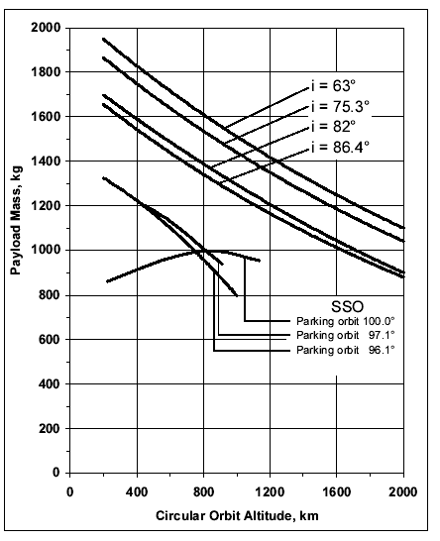
Figure 9 The published launch capability of the EUROCKOT launcher for payloads into sun synchronous orbit.

Ground Operations
There is a requirement for an S-band communications system and operations centre to provide command and status/health monitoring of the payload and platform and an X-band data downlink for the higher rate instrument science data.
The X-band system will be located at the S-band site such that common system monitoring and logistics support can be provided.
The payload organisation will provide an engineering team to assess the detail performance of the instruments and support the operations centre organisation in general health/safety monitoring.
Figure 10 Communications Overview

Orbit /Pass Characteristics

Ground Stations

S-Band
Uplink and downlink supporting CCSDS standard telemetry and tele-commanding functions will be used.

X-Band
Two identical systems will be used for redundancy.
- System Functions
- RF system
- Data Storage System
- Data Transmission System
Full raw data by courier - e.g. Compact Discs
- Instrument Data ‘Snapshot’ Processor.
- Engineering Data Processor

Operations Centre Tasks
The following tasks/functions will be performed by Operations Centre to provide mission control and planning.

System Development - Pre-Launch
- Planning and organisation of communications systems
- Develop knowledge of spacecraft platform and payload
- Operational procedure development

Orbital Phase
- Spacecraft (Platform and Payload) housekeeping Health and Safety monitoring
- Preparation of pass report for forwarding to Payload engineering team.
- Flight dynamics support
precise orbit determination (note: a GPS system may be used on platform)
- Attitude reconstruction
- Pass predictions for S-band and X-band antenna pointing
- X-Band Receiving Station Support to provide local operator for system maintenance and logistics support system monitoring (remote or local)
- Preparation of system status report

Activity Levels
Launch and Early Orbit Phase/Platform Commissioning typical level of support:
12 hour day for 3 weeks
Payload Commissioning
Typical S-band system support: 8 hour normal working hour day for 4 weeks
Operational Phase
Up to 2 contacts/day from appropriate S-band ground station - see section 9.1
X-Band Downlink System Support
14 orbits /day

Science Data Handling
Monitor predetermined engineering related parameters from the preliminary processed science data from the X-band station when necessary, and in particular for fault finding diagnostics.

Additional Ground Station Support
There are also opportunities for using X-band antenna in Australia - Cairns, Townsville, and Darwin are all possible low latitude sites. Cairns already has receiving stations for AVHRR and SeaWiFS at the Australian Institute of Marine Science (AIMS). And the Bureau of Meteorology at Darwin has strong involvement in the TRMM mission, an AVHRR reception station, and a full cyclone warning system. Using a receiving station at Darwin would give an important potential user group direct real-time access to “OCEAN CURRENTS” data. Further investigations of these possibilities will take place during any subsequent phase A.

Science Data Centre
Raw data will arrive from the X-Band reception stations by courier on a suitable distribution media (i.e. CD-ROM, Exabyte tape, etc.). Faster real-time science data links to the reception facilities, although desirable, are too expensive and cannot be justified. Little of the science is lost through the delays involved in off-line processing. It anticipated that the “OCEAN CURRENTS” Processing Facility will deliver data directly to the wider user community.
The design and implementation of the data segment will be based heavily on the experience gained by the previous ATSR missions, ATSR-1, ATSR-2 and AATSR, and particular regard will be paid to lessons learnt from these missions. All the costs presented here for the ground segment development and post launch operations are based on detailed factual knowledge of the actual costs incurred in the operation of the ATSR-2 facilities, and the development of the AATSR Prototype Processor for Envisat.
The heritage and status of each of the “OCEAN CURRENTS” geophysical processing algorithms is shown in the table below, the plans for developing the facility further will be detailed during the Phase A/B study.
Table 1 Heritage and Status of “OCEAN CURRENTS” geophysical processing algorithms
Algorithm | Current Status | What is required for “OCEAN CURRENTS”
Geolocation | No algorithm | New algorithm
Calibration | ATSR-1,-2 and AATSR versions exist | Modification to suit “OCEAN CURRENTS”
Cloud Screening | ATSR-1,-2 and AATSR versions exist | Modification to suit “OCEAN CURRENTS”
Spatially-averaged  Products | ATSR-1,-2 and AATSR versions exist | Modification to suit “OCEAN CURRENTS”
Ocean currents | Methods exist (see earlier sections) | New algorithms implementing methods

Concluding Remarks
From the literature review presented in the previous sections it is clear that there is a major role for satellite SST observations in the determination of ocean currents, and that the addition of an SST capability to a radar altimeter mission would be particularly beneficial.
From the data requirements we have identified, the SST sensor would need to be a high performance infrared sensor, despite the fact that cloud cover will pose some coverage problems, as microwave sensors simply do not have the spatial and radiometric resolution to observe the ocean features that are important for ocean current determination. For cost and risk reasons the current plan would be to fly an ATSR-type instrument as the design already exists so could be adapted for this specialist purpose fairly straightforwardly and at minimum cost, however because of the ATSR’s limited swath it may be necessary to fly more sensors to achieve the required temporal coverage. There are designs now available for wider swath instruments but they are at an early stage of development and it would be costly and carry considerable risk at this stage to base a mission around these designs.
A single satellite system to observe SST could be but together for around €30-40M plus the costs of the ground segment and, if required, a radar altimeter.

References
Jones, M., Allen, M., Guymer, T., and M. Saunders, Correlations between altimetric sea surface height and radiometric sea surface temperature in the South Atlantic, J. Geophys. Res., 103, C4, 8073-8087, 1998.
Kelly,K.A., and Strub, P. T. Comparison of Velocity Estimates from Advanced Very High Resolution Radiometer in the Coastal Transition Zone, J. Geophys Res., 97, C6,9653-9668,1992.
Lea, D., D.Phil. Thesis Oxford University, 2001.
Mutlow, C.T., A.M. Závody, I.J. Barton, and D.T. Llewellyn-Jones, Sea Surface Temperature Measurements by the Along Track Scanning Radiometer (ATSR) on ESA’s ERS-1 Satellite: Early Results, J. Geophys. Res., 99, 22,578-22,588, 1995.
Simpson, J.J., and J. I. Gobat, Robust Velocity Estimates, Stream Functions, Simulated Lagrangian Drifters from Sequential Spacecraft Data, IEEE Trans. Geosci. Rem. Sens.,32, 474-493, 1994.
Svejkovsky, J., Sea Surface Flow Estimation From Advanced Very High Resolution Radiometer and Coastal Zone Color Scanner Satellite Imagery : A Verification Study, J. Geophys Res., 93, 6735-6743,1988.
Vigan, X., Provost, C., and G. Podesta, Sea surface velocities from sea surface temperature image sequences 1. Method and validation using a primitive equation model output , J. Geophys. Res., 105, C8, 19,499-19,514, 2000.
Vigan, X., Provost, C., and G. Podesta, Sea surface velocities from sea surface temperature image sequences 2. Application to the Brazil-Malvinas Confluence area., J. Geophys. Res., 105, C8, 19,515-19,534, 2000.
Závody, A.M, Mutlow, C.T., And Llewellyn-Jones, D.T., Cloud Clearing Over The Ocean In The Processing Of Data From The Along-Track Scanning Radiometer (ATSR), J. Atmos. Oceanic Technol., 100, 595-615, 2000.
Závody, A.M, Mutlow, C.T., And Llewellyn-Jones, D.T., A Radiative Transfer Model For Sea Surface Temperature Retrieval For The Along-Track Scanning Radiometer (ATSR), J. Geophys. Res., 17, 937-952, 1995.
Zhang, Y.-C. , W. B. Rossow, and A. A. Lacis, Calculation of surface and top of atmosphere radiative uxes from physical quantities based on ISCCP data sets, 1., Method and sensitivity to input data uncertainties, J. Geophys. Res., vol. 100, pp. 1149 – 1165, 1995.

This could be achieved by absolute knowledge at intervals with an associated algorithm for interpolating between these measurements.

