Co-ordinated Approach to Markets for Marine Earth Observations

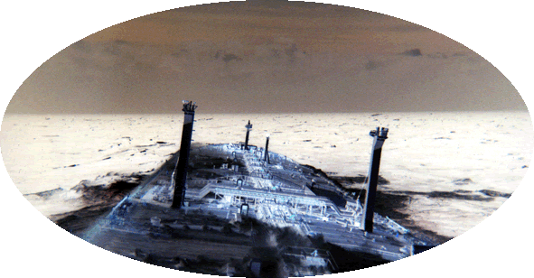

CAMMEO

User Guide

Metoc NRT web mapping system

Document Number: SOS-ESA-CAM-UG-1

Issue Number: Draft
Date: 3 March, 2005
Customer: ESA EOMD, Longer Term Activities
Contract: 17737/03/I-IW

Author: ……………………

Approved: ……………………

Introduction
This document present the user guide for the Metoc web mapping system for the display of EO wind and wave information together with forecasts in near real-time. This has been developed as one of the service lines under the ESA funded CAMMEO project.

CAMMEO is a market development activity under the ESA Earth Observation Market Development programme, and addresses line 4 of the service and market segments: “Enhanced Forecasting for Marine Transport and Search & Rescue Operations”.

Four services have been developed under CAMMEO with the overall aim of increasing use of EO wind and wave measurements in operational services. These services are:

- Near real-time EO wind and waves in information systems for shipping (NRT_RAW)
- Near real-time winds for adjustments to search and rescue areas (NRT_S&R)
- Near real-time EO winds and waves for corrections to wave forecasts (NRT_WFC)
- EO wind and wave statistics for design and certification (STAT_DC)

The Metoc web mapping system forms the main part of the service NRT_RAW.

Access
Metoc is available at the following URL via a standard web browser*:

http://metoc.met.no

*Browser requirements:

Internet Explorer 5.5, 6.0 (reduced functionality on 4.0, 5.0)
Netscape 7 (this recommended for Mac)
Mozilla 1.7
Opera 7.5

Overview
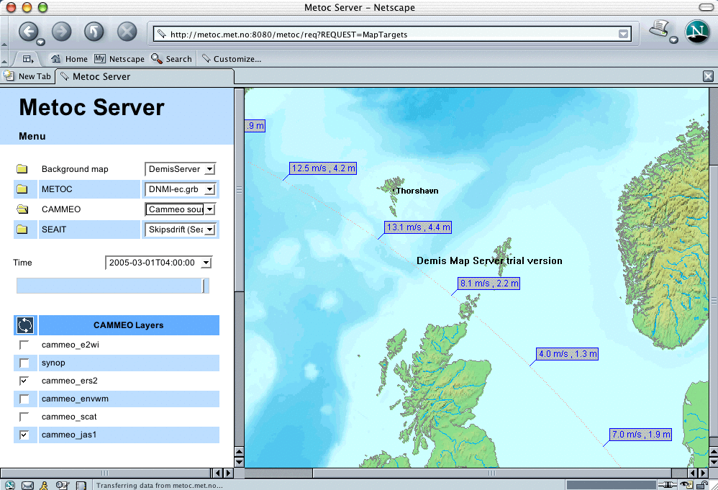

There are 2 panels in the Metoc system, the data panel (left) and the mapping panel (right).

Data panel
The information to be displayed and the time of interest are selected on the data panel. To activate layers click on the yellow folder, select data category from the menu to the right, then check required layers from the list below. The time menu displays all times for which selected data and model information are available. The time of interest is given in the time menu (1 hour intervals) and can be selected directly.

The EO data is selected via the CAMMEO layers (there is only one menu option for the CAMMEO folder). The following sources are available:

- cammeo_e2wi ers2 scatterometer winds (broad swath speed and direction)
- synop non EO synoptic observations (ships etc)
- cammeo_ers2 ers2 altimeter waves and winds (narrow swath wave height, period and wind speed)
- cammeo_envwm envisat wave mode (sporadic wave period and direction)
- cammeo_scat quikscat scatterometer winds (broad swath speed and direction)
- cammeo_jas1 jason1 altimeter waves and winds (narrow swath wave height, period and wind speed)

Once layers are selected, the dark blue “refresh button” to the left of the layers title needs to be clicked to update the map.
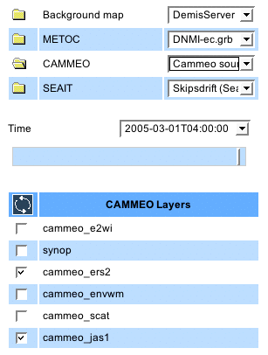

Mapping panel
The mapping panel displays the map and selected data layers for the selected time slot. Mapping is controlled by functions given in the toolbar at the top left of the mapping panel.

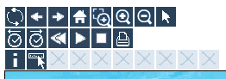

Hovering the mouse over toolbar items displays their function. From top left to bottom right these are:

Refesh map; Previous view; Next view; First view; Select zoom area, Zoom out, Zoom in, Set center
Previous time; Next time, Rewind, Animate, Stop animations, Print
Feature information, Tooltip (information popup)

There are also other advanced functions used with forecast data but blanked out for EO data only display. The latter two functions above are used to display details of a data point, either by selecting “Feature information” and clicking on the point (feature information given in a separate window) or by selecting the “Tooltip“ feature that gives popup information display when the mouse is hovering over a point.

Getting started
On accessing the Metoc system the following initial steps are suggested for browsing CAMMEO EO data:

- On the mapping panel select “Zoom out“ icon and click on map once near area of interest to zoom out
- Select “Set Center“ and recenter map if required
- On the data panel select CAMMEO yellow folder
- Check all CAMMEO data sources except “synop”
- Select most recent time from time menu
- On the mapping panel click “Previous time“ icon repeatedly to browse most recent EO data
- To investigate data in more detail zoom in using “Select zoom area“ and / or select “Feature information” to display details of an individual data point.

To add forecast layers to the mapping display select the yellow folder for METOC on the data panel, and select required forecast source from the menu on the right. For example DNMI-ec.grb gives N Atlantic forecasts. Check required layers from the list below and refresh the map.

Support
For user support please contact Ellis Ash, +44 (0)1483 421213, email E.Ash@satobsys.co.uk

