TOPEX B Side Altimeter Wind Speed and Significant Wave Height Calibration (1999-2001)
P.D. Cotton
Satellite Observing Systems
17 December 2001

1. Introduction
This note describes the calibration of the TOPEX B altimeter significant wave height and ocean wind speed measurements against in situ buoy data.
TOPEX v3 Geophysical Data Records data were used, as supplied by AVISO. The in-situ data were from US, Canadian and UK offshore buoys. These data were available courtesy of the US National Data Buoy Centre (NDBC), Environment Canada (EC) and the UK Meteorological Office (UKMO). Data from buoys operated by the latter two agencies were retrieved from the NDBC web site.

2. Data Processing

TOPEX GDR Data
For this study we used significant wave height and wind speed data extracted directly from the 1 Hz TOPEX GDR (v3), covering the period March 1999 to July 2001. Apart from quality checks (see below) no further processing of these records took place.

TOPEX v6 GDR Quality Checks

Parameter | Check
GDR/OPR flags | geo_bad_1: 1 altbad_2:4,6
σ0 range | 0-20
Hs range | 0-25
U10 range | 0-50
sdHs range | > 0.000001  <0.1 .or. sdHs <0.1Hs
sdH range | <0.1
Attitude | <1.0

Buoy Data
Hourly records of wind, wave and other surface meteorological data were retrieved from a selection of 39 open ocean data buoys. These buoys included 24 US NDBC buoys (from the north western North Atlantic, north eastern and central North Pacific), 6 Canadian offshore buoys (also from the north western North Atlantic and north eastern North Pacific), and 9 UK Meteorological Office offshore buoys (from the north-eastern North Atlantic and North Sea). More details are given in a calibration report for Geosat Follow On (http://www.satobsys.co.uk/Projects/CalVal)
Where appropriate the buoy winds were adjusted to 10m according to Dobson [1981].

Extraction of coincident altimeter/buoy data
Extraction details are given in the GFO report (see above)

Calibration Procedure
Details of the orthogonal distance/principle component regression procedure used are given in the GFO report. Results are given below.

Results
Four sets of regressions were carried out, one comparing TOPEX B to the combined buoy data, and a further three comparing TOPEX B separately to each of the individual buoy data sets. Results (Equations 1 and 2, and Tables 1 and 2) are given in terms of the indicated linear correction required for the TOPEX B altimeter data.

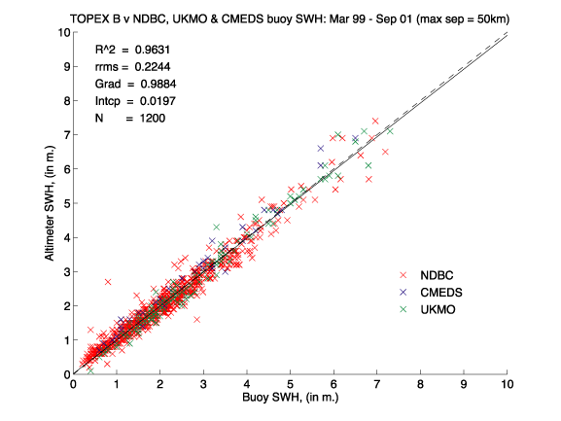
Figure 1. Co-located TOPEX B and buoy significant wave height data (03/99-07/01). NDBC (red), EC (blue) and UKMO (green). The ODR fit is shown as a solid black line, the line of perfect match (gradient=1.0, intercept =0.0) as a dashed line.

Combined Data (NDBC, Canadian, and UKMO data)

Significant Wave Height
The orthogonal distance regression yielded the following calibration correction:
Hs(ODR) = 1.0118 Hs(TOPEX) - 0.0199 rms=0.2244 m (1)
95% conf. limits 1.0006-1.0229 -0.0456 - +0.0058
R² = 0.9631, N=1200

Equation (1) and Figure 1 show that, when all buoy data are considered, the ODR line and line of perfect match (intercept of 0.0 and gradient of 1.0) are almost coincident. However, on close inspection we can see that the TOPEX B altimeter very slightly underestimates Hs. The calibration gradient is indeed significantly different from 1.0 (at the 95% level), albeit by only just over 1%. The intercept is not significantly different from 0.0. These values indicate a remarkably good agreement between TOPEX B and buoy data. This near perfect agreement together with a low residual root mean square of 0.2244 m, indicate that TOPEX B is providing a high quality significant wave height data set.
The co-located data range from < 0.5 to 7 m.
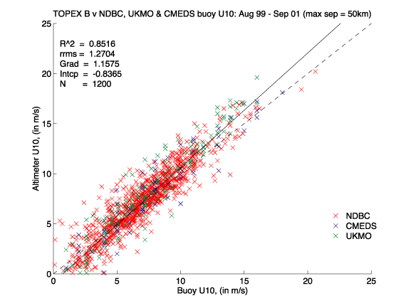
Figure 2. Co-located Topex B and Buoy 10m wind speed data (03/99-07/01). NDBC buoy data (red), Environment Canada buoy data (blue) and UK Met. Office Buoy data (green). The ODR line is shown as a solid black line, the line of perfect match (i.e. gradient=1.0, intercept =0.0) is given by a dashed line.

10m Wind Speed
The orthogonal distance regression yielded a suggested calibration correction of:
U10s(ODR) = 0.8639 U10 (TOPEX) + 0.7227 rms=1.2704 ms⁻¹ (2)
95% conf. limits 0.8443- 0.8836 0.5611 – 0.8843
R² = 0.8516, N=1200
From the relative positions of the dashed line (perfect match between altimeter and buoy) and solid line (ODR line) on Figure 2 we can see that TOPEX B slightly overestimates low wind speeds and underestimates higher wind speeds (Ubuoy > 5.3 ms⁻¹ ). At 0.86, the gradient is significantly lower than 1.0 (at the 95% level), and the intercept is significantly higher than 0.0, at 0.72 ms⁻¹. The consequence is that for Ubuoy = 20 ms⁻¹ this underestimate reaches 2 ms⁻¹. The residual root mean square of the fitted data is 1.2704 ms⁻¹, which is less than that seen in analyses of data from other contemporary altimeters (GFO, ERS-2). The range of wind speeds covered by the data is <0.5 ms⁻¹ to > 20 ms⁻¹.

Against Individual Buoy Sets(NDBC, EC and UKMO)

The TOPEX B data were also regressed separately against the data supplied by the three different buoy agencies. The results of these regressions are summarised in Table 1 (significant wave height) and Table 2 (10m wind speed).

Significant Wave Height
Table 1 shows that, when compared to NDBC data, the calibration gradient for TOPEX B Hs is higher (significantly different at the 95% level) than that given when TOPEX B is compared to the EC and UKMO data. The results from the UKMO and EC data sets are not significantly different from each other. The NDBC intercept is also significantly lower from that of the UKMO data.

Data set | Gradient | 95% conf interval | Intercept (m) | 95% conf interval | r.r.m.s (m) | R² | N
NDBC | 1.0376 | 1.0226 1.0525 | -0.0674 | -0.0996  -0.0352 | 0.2423 | 0.9479 | 992
EC | 0.9427 | 0.9085  0.9768 | 0.0299 | -0.0688  0.1286 | 0.2012 | 0.9788 | 67
UKMO | 0.9619 | 0.9386  0.9851 | 0.1275 | 0.0577  0.1974 | 0.2162 | 0.9791 | 143
Combined | 1.0118 | 1.0006  1.0229 | -0.0199 | -0.0456  0.0058 | 0.2244 | 0.9631 | 1200
Table 1. Linear calibration coefficients for altimeter significant wave height derived from orthogonal distance regressions against in situ data.

This effect was also seen in comparisons of GFO Hs against the buoy data, and again suggests that significant wave height measurements from the NDBC data set are not entirely consistent with those from the EC and UKMO data. This could be an environmental effect acting either on the altimeter or the buoy measurement or an instrumental effect (perhaps due to slight variability in calibrations). However, note that Cotton et al, [1998] found differences in Hs calibrations between altimeter and NDBC measurements from different regions.

10m wind Speed

From Table 2 we see that the gradients from the regressions against the NDBC and EC buoy data sets are consistent with each other (i.e. within 95% confidence limits), as are those against the EC and UKMO data sets (but not UKMO and NDBC). All regressions show gradients significantly lower than 1.0.
The intercepts from the three buoy data sets cannot be separated (at the 95% confidence level), but they are all significantly higher than 0.0.

Data set | Gradient | 95% conf interval | Intercept (ms⁻¹) | 95% conf interval | r.r.m.s (ms⁻¹) | R² | N
NDBC | 0.8801 | 0.8571  0.9032 | 0.6385 | 0.4553  0.8217 | 1.2443 | 0.8386 | 992
EC | 0.8830 | 0.8102  0.9664 | 0.6802 | -0.0415  1.4044 | 1.4255 | 0.8817 | 67
UKMO | 0.7998 | 0.7562  0.8434 | 0.9540 | 0.5413  1.3668 | 1.2870 | 0.8987 | 143
Combined | 0.8639 | 0.8443  0.8836 | 0.7227 | 0.5611  0.8843 | 1.2704 | 0.8516 | 1200
Table 2. Linear calibration coefficients for altimeter wind speeds derived from orthogonal distance regressions against in situ data.

Summary
A comparison of TOPEX B data with co-located buoy data indicates that the TOPEX significant wave height and wind speed measurements are of high quality.
The ODR regressions indicate that the TOPEX B altimeter very slightly underestimates significant wave heights, by just over 1% (Equation 1).
The ODR regressions on wind speed data (Equation 2, Table 2) indicate a gradient significantly lower than 1.0 (0.86 when compared to the combined buoy data) and an intercept significantly higher than 0.0 (0.72 when compared to the combined buoy data). The combined effect of this calibration is to raise lower wind speeds, and reduce higher TOPEX B winds. The transition occurs at 5.3 ms⁻¹.
A subsidiary, but interesting, point to note is the apparent discrepancy between the NDBC buoy measurements of wave heights, and those from EC and UKMO. This effect has also been noted in a calibration of GFO data.

References
Dobson, FW, 1981: Review of Reference Height for and Averaging Time of Surface Wind Measurements at Sea, Marine Meteorology and Related Oceanographic Activities Report No. 3, WMO, Geneva, 64pp.
P.D. Cotton
Satellite Observing Systems
15, Church Street Phone +44 (0)1483 421213
Godalming, (direct +44 (0)161 439 4768)
Surrey GU7 1EL, UK d.cotton@satobsys.co.uk

