

Development of SAR Altimetry Mode Studies and
Applications over Ocean, Coastal Zones and Inland Water (SAMOSA)

ESRIN Contract No. 20698/07/I-LG

WP6 Technical Note

NOCS Coastal Zone Scenario

Paolo Cipollini

National Oceanography Centre, Southampton

July 2009

SAMOSA_WP6_NOC_v1.0
© The Copyright of this document is the property of National Oceanography Centre, Southampton (NOC). It is supplied on the express terms that it be treated as confidential, and may not be copied, or disclosed, to any third party, except as defined in the contract, or unless authorised by NOC in writing.
National Oceanography Centre Southampton
European Way, Southampton
SO14 3ZH, United Kingdom
Tel: +44 (0)23 80596413 Fax: +44 (0)23 80596400

Document signature table

 | Name | Institution | Signature | Date
Prepared by | P. Cipollini | NOCS |  | 27/7/2008
Approved by | P. Cipollini | NOCS |  | 27/7/2008
Authorised by | P. Cipollini | NOCS |  | 27/7/2008

Dissemination

To: | Copies | Means
Jérôme Benveniste | 1 | Jerome.Benveniste@esa.int
Salvatore Dinardo | 1 | Salvatore.Dinardo@esa.int
David Cotton | 1 | d.cotton@satoc.eu
Keith Raney | 1 | Keith.Raney@jhuapl.edu
Cristina Martin-Puig | 1 | cristina.martin@starlab.es
Ole Andersen |  | oa@spacecenter.dk
De Montfort University, Philippa Berry | 1 | pamb@dmu.ac.uk

Issue record

Issue No. | Issue Date | Sections affected | Relevant information
0.5 | 27/07/09 | - | Draft

Table of contents
Document signature table 2
Dissemination 3
Issue record 4
Table of contents 5
1. Introduction 6
2. Design of the Coastal Zone Scenario 6
3. Crymps Output Initial Analysis 9

Introduction
In section 4 of the SAMOSA Technical Note 1 (TN1: “State of the art assessment”) we have discussed in detail the beneficial characteristics that make the SAR altimeter a very promising candidate for the monitoring of the coastal zone, a domain that until recently was excluded from the applications of standard (conventional pulse-limited) altimetry [now the COASTALT and PISTACH project, respectively sponsored by ESA and CNES, are investigating the extension of standard altimetry to this domain]. Some resources within SAMOSA WP6 have been allocated to an assessment of the capabilities of the delay-Doppler instrument in proximity of the coast, by means of runs of dedicated coastal scenarios on CRYMPS. The criteria behind the design of the coastal scenarios have been introduced in TN1 alongside a number of draft configurations for the coastal scenario(s) (labeled CN1-CN4, CO1-CO4, CI1-CI4 for normal, oblique and parallel/island-like features, respectively), with the proviso that they should be merged on the basis of subsequent experience gained from the other CRYMPS runs, in order to keep the number of computationally intensive simulations to a minimum. When the preliminary open ocean scenarios were run, it became apparent that not only the simulations were more intensive than expected but also that the processing and interpretation of the results were very time-consuming when compared to the limited manpower allocated to the task. It was therefore decided by the SAMOSA partners to greatly reduce the number of runs; for the coastal zone this means focusing on features oriented orthogonally to the along-track direction, leaving the investigation of more complicate geometries to future extensions of the project. As a result NOCS have designed a single coastal zone scenario that nevertheless encompasses several of the most significant phenomena (surface topography, coastal setup, sharp sigma0 variations, wave steepening) that are present in the coastal ocean. This section reviews the rationale behind the design of the coastal scenario, describes the relevant DEM, analyzes qualitatively the output of the CRYMPS run and issues some recommendations for further analysis.

Design of the Coastal Zone Scenario
TN1 section 4.3 had illustrated the criteria, which have informed the design of the coastal ocean scenario SCST; these are briefly recalled here.
Obviously one important issue in the coastal environment that differentiates it from the open ocean is the presence of altimeter returns from land: to simulate land it is necessary to generate a specific DESM with appropriate variability for height (DEM), polar angle and backscatter. Moreover the scales of variability of sea surface topography and roughness (hence backscatter) in the coastal zone are typically much shorter (~1-10 km) than those offshore: a realistic coastal scenario must contain at least some rapid transitions of these two quantities, which can include an increase of sea level towards the coastline to simulate coastal setup by wind and waves. The scenario can also have changing wave/swell parameters to simulate steepening and shortening of waves when approaching land in shallow bottom.
The SCST scenario is based on the above considerations and is schematized in figure 1. It is exactly on the same grid (10m resolution) as the previously used scenarios, with a useful length of 8s (corresponding to 54 km along-track) plus ~4s of extra data on each side, needed to form complete echoes.
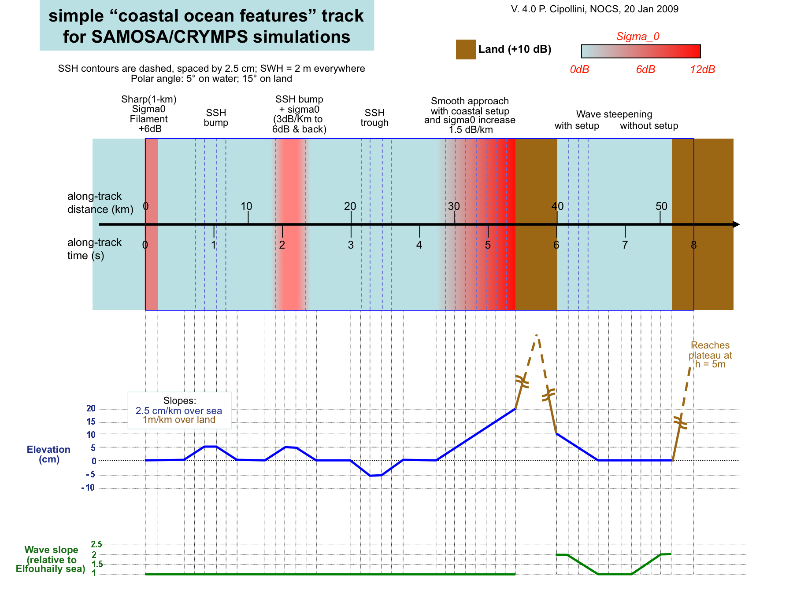
Figure 1 – schematic of the SCST scenario for CRYMPS
The scenario presents a number of short-scale variations in sea surface topography and sigma0 (including a sharp sigma0 filament), a ‘island’ feature between km36 and 40 with coastal setup on both sides, followed by a small enclosed basin with wave steepening. Slopes are 2.5 cm/km over sea and 1m/km over land. Sigma0 ranges between 0 and 12 dB, and is set at 10 db for land based on the experience of the Project partners. Swh is 2m and the increase in wave steepness (with respect to the Elfouhaily sea spectrum) at the coasts of the small 'basin' between km 40 and km 51, simulated by compressing the wave field in the along-track direction, is up to a factor 2 rather than the factor 4 originally proposed. These values have been prompted by sampling considerations: with swh=2m, the lower wavelength end of the wave spectrum (at -3dB w.r.t. the maximum) is ~42m which, when compressed along-track by a factor two, stays just within the Nyquist condition for a 10-m sampling.
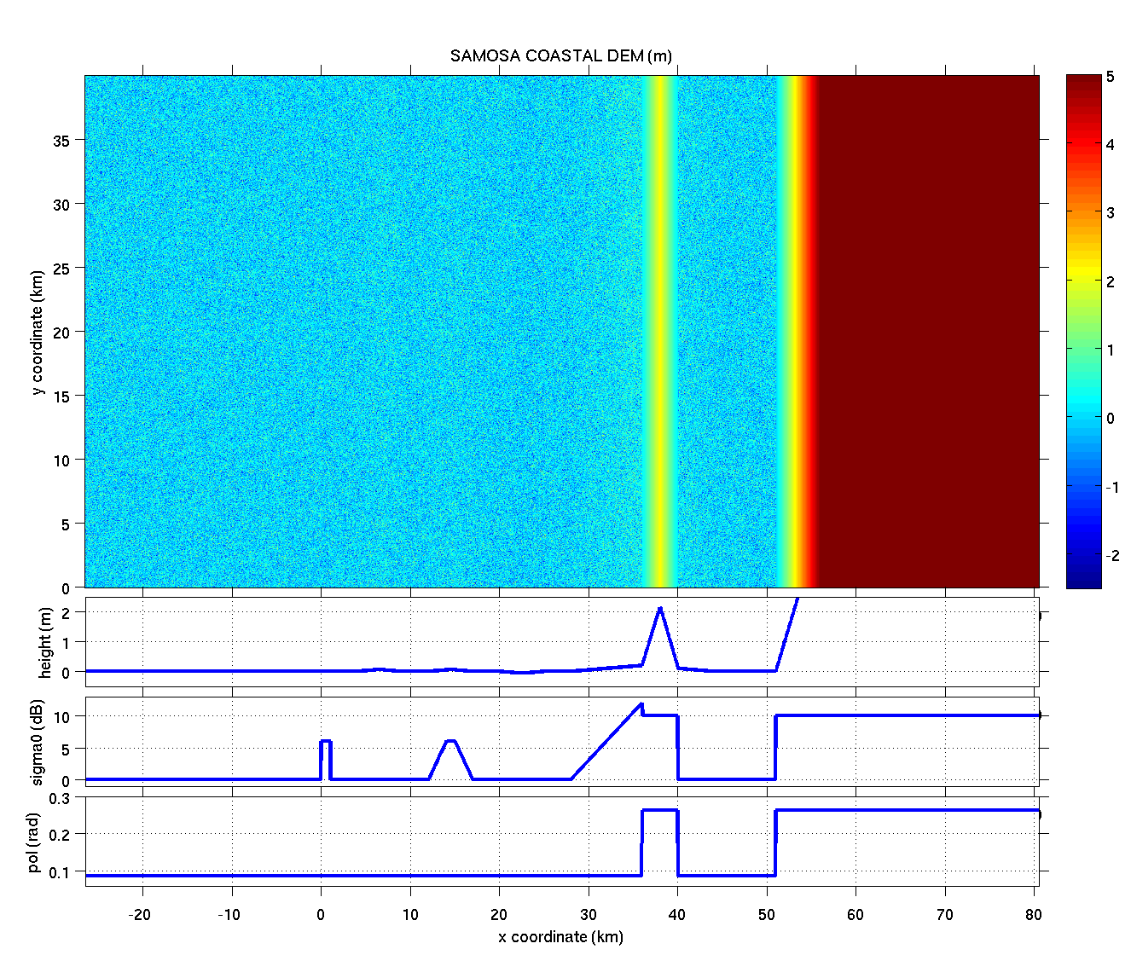
Figure 2 – the SAMOSA SCST DEM, and associated profiles of height, sigma0 and polar angle.
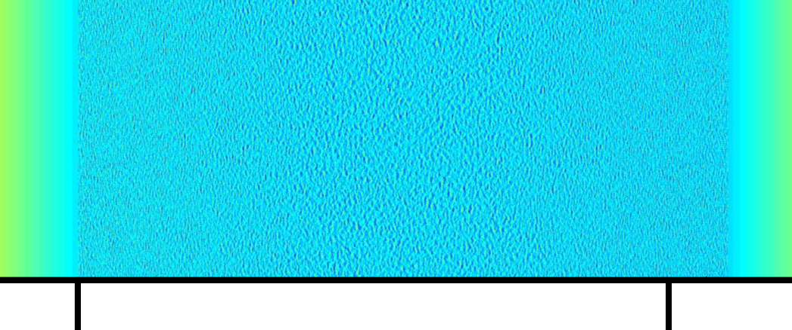
Figure 3: enlarged view of the basin between km 40 and km 51 (red rectangle in figure 2), showing the effect of the along-track compression of the wave field that has been used to simulate coastal wave steepening. Colour scale is the same as in figure 2.
After some discussion with the various SAMOSA partners the polar angle was set constant at 5 degrees over water and 15 degrees over land. The upper panel of figure 2 shows the 2-D view of the DEM, while the lower panels display the along-track profiles of elevation (excluding the wave field), sigma0 and polar angle. A zoom over the enclosed basin between km 40 and km 51 is presented in figure 3, and shows the effect of the along-track compression of the wave field that has been used to simulate coastal wave steepening.

Crymps Output Initial Analysis
The initial analysis of the CRYMPS output presented in this section is centered on the comparison of the SAR waveforms with the LRM waveforms. A cumulative line plot of a subset of the waveforms (figure 4) shows clearly that in both cases the waveforms have a well-defined shape that conforms to the expected theoretical models (the open-ocean echo models has been briefly recalled in TN1 section 2.3.5, while the SAR Altimeter Mean Return Waveform model has been fully developed in the WP5 documents). This can be considered an encouraging result as it demonstrates the usefulness of the simulations in producing realistic signals that can be re-tracked based on physically-based echo models.
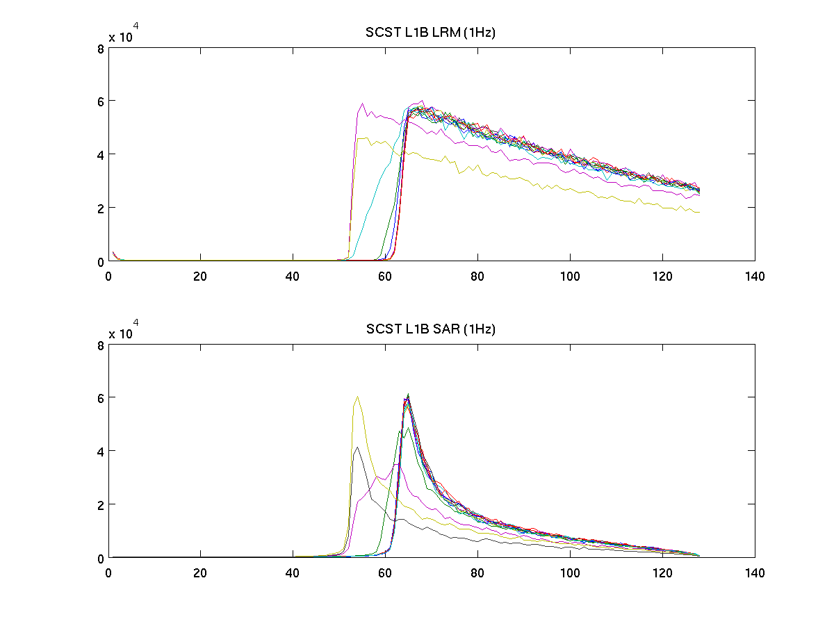
Figure 4: line plot of the waveforms for the LRM output (upper panel) and SAR panel (lower panel. Every 10th waveform has been plotted. The x-axis values represent gate number.
The full waveform spaces from the two instrument modes are presented in figure 5 alongside the DEM and the elevation and sigma0 profiles, for ease of comparison. It must be noted that these have been obtained with a fixed tracker mode.

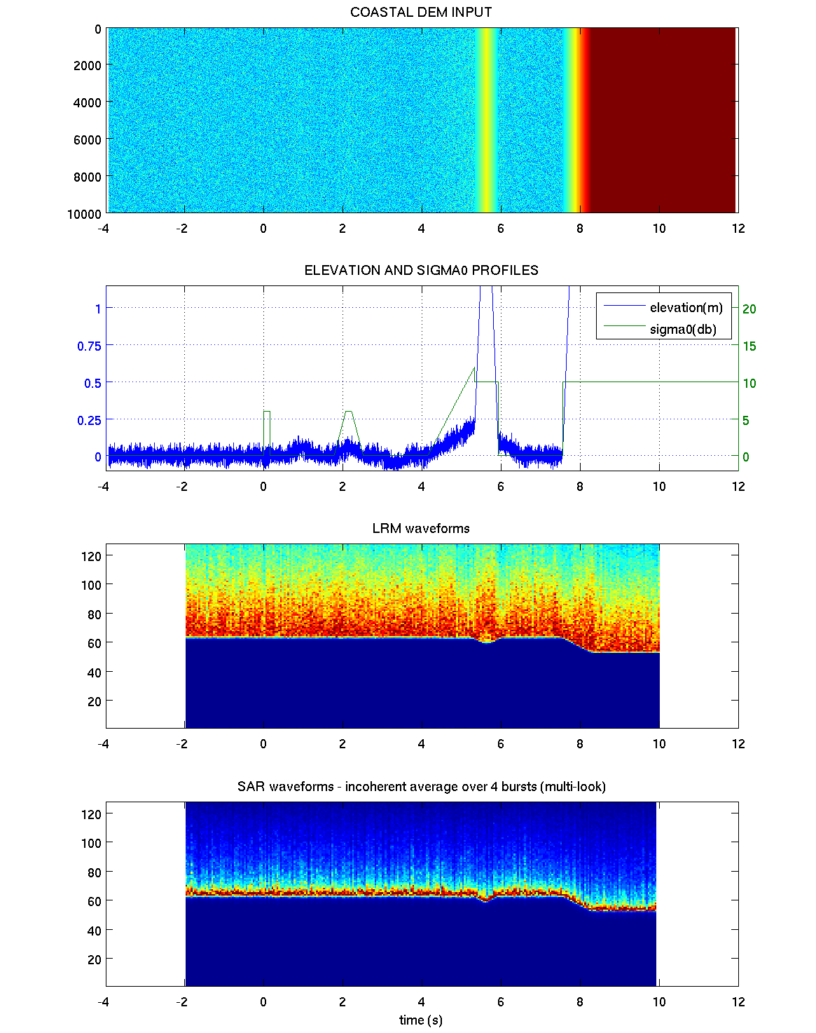
Figure 5- a) coastal DEM (SCST); b) elevation and sigma0 profiles; c) space of the LRM waveforms; d) space of the SAR waveforms. In c) and d) y-axis values represent gate number.
Both sets of echoes show clearly the main variations in elevation due to the land profile, whereas the effect of the smaller features in the sea surface topography is not readily apparent and will need re-tracking in order to be assessed. No effects of variable sigma0 can be seen in the plots, but this is due to the fact that the waveforms have not been rescaled to their true power value. It is also not clear from the plot if and how the waveforms are affected by the wave steepening in the enclosed basin. Clearly, power scaling and re-tracking of the waveforms are needed for a proper quantitative analysis.
For the purposes of the initial - qualitative - analysis, it is nevertheless rather interesting to zoom on the region of the DEM with the ocean/land transition and the land topography, shown in figure 6. In those figure we have superimposed (white lines) the position of the half-power tracking point expected on the basis of the DEM elevation profile, using a bin gate width of 0.45 m for the conversion between height and gate number. By comparing the two sub-plots in figure 6, and especially when using the expected tracking point as a visual aid for the comparison, one can easily appreciate the increased ability of the SAR altimeter to follow the elevation profiles: the peaks and ‘corners’ in the SAR sub-plot are sharper, while the LRM waveforms show much more ‘rounded-up’ or ‘smoothed’ transitions. This is obviously expected on the basis of the nominal response of the instrument in the two different modes (and in particular because of the differences in the footprints), and it is encouraging in view of a full retracking of the waveforms.
We can conclude that:
- the coastal scenario simulation (SCST scenario) has been successful in producing a set of waveforms that conforms well to the expected models;
- no power scaling has yet been performed, so the effects of sigma0 could not be assessed;
- the SAR waveforms display an increased ability to reproduce sharp variations in the topography, which is very encouraging and calls for a proper quantitative analysis based on this and future DESMs;
- re-tracking of the waveforms is now needed for a full quantitative analysis of the coastal ocean capabilities.

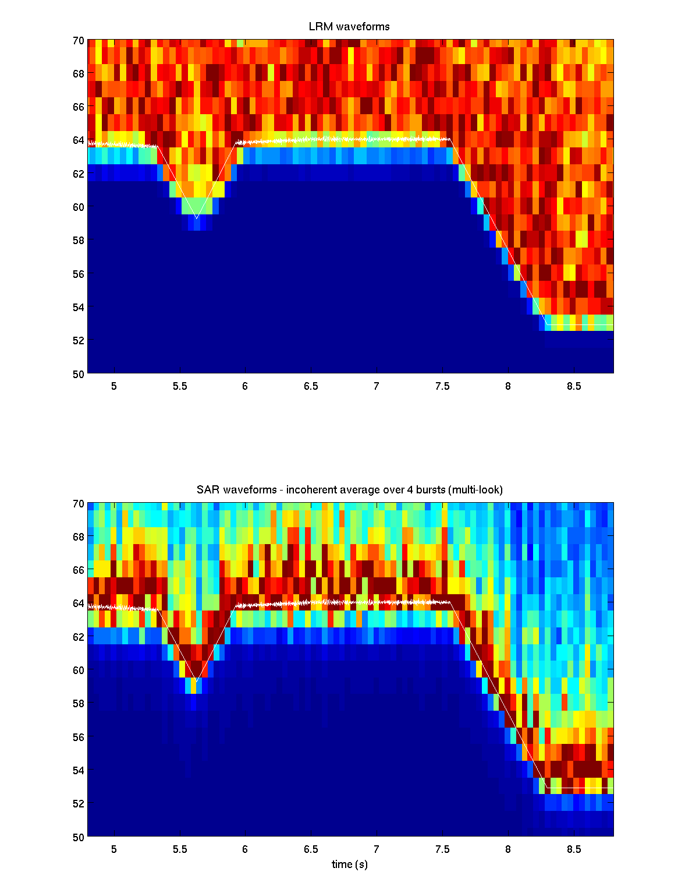
Figure 6 – Zoom on the LRM and SAR waveforms at the ocean/land transitions. The superimposed white lines indicate the expected position of the half-power tracking point on the basis of the DEM elevation profile, using a bin gate width of 0.45 m. In both diagrams y-axis values represent gate number.

